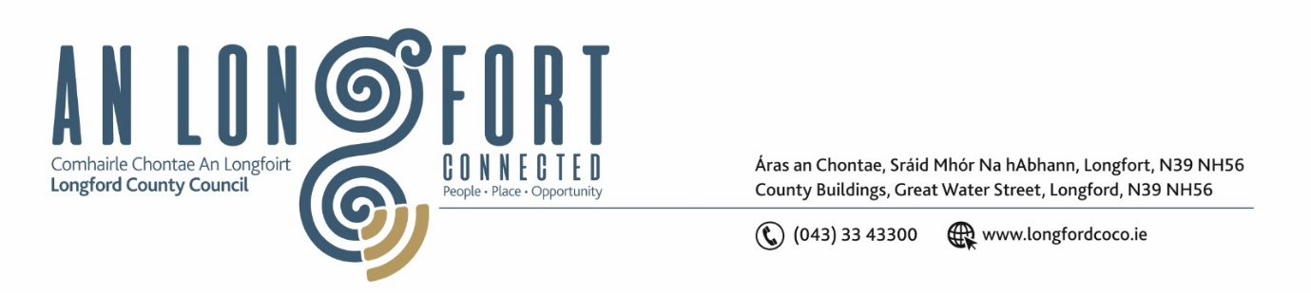

**GRANARD MUNICIPAL DISTRICT**

***Please note meeting will be held in the Council Chamber***

**16 September 2024**

**To: Each Member of Granard Municipal District.**

**Dear Member,**

You are requested to attend a Meeting of Granard Municipal District to be held in the Council Chamber on **Monday, 23 September 2024 at 3:30pm** to transact business, as set out on the Agenda hereunder.

**Yours sincerely**,

______________________

**Claire McNabola,**

**Meetings Administrator**

**AGENDA**

Prayer before meeting.

**1.** Confirmation of Minutes as follows:

1. Granard Municipal District Meeting held on 22 July 2024 – enclosed.
2. Granard Municipal District Committee Meeting held on 22 July 2024 – enclosed.

**2.** Matters arising from Minutes.

**3.** Declaration of Interest by Members.

**4.** Management Report incorporating Area Engineer’s Progress Report

**5.** Roads - 3 Year Programme

**6**. Notice of Motions

**Cllr Paraic Brady**

1. I call on Longford County Council to carry out a safety scheme at Glannagh Ballinalee as there were a number of accidents at this bend. The landowner is in agreement.

**Cllr Padraig McNamara**

1. I call on Longford County Council to provide an Update on GMCE joint project funded since 2018.
2. I call on Longford County Council to introduce traffic calming measures in Abbeylara Village as there have been numerous complaints of speeding reported by residents.

**Cllr Garry Murtagh**

1. I call on Longford County Council to raise pedestrian crossing/s in :

* Ballinalee (traffic lights)- at the entrance to the forest walk on the Ballinalee /Granard road
* Aughnacliffe (flashing lights) x 2 - school to church & the junction at Leebeen Park

1. I am calling on Longford County Council to install wheelchair accessible swing in Leebeen park and any other suitable equipment for children with disabilities to enhance a more inclusive play experience.

**Cllr David Cassidy**

1. I call on Longford County Council to carry out a traffic speed survey on the basis of speeding issues in the villages of Ennybegs, Aughnacliff and Ballinamuck.
2. I call on Longford County Council to cut back overgrowth which has become an issue to pedestrians on the Drumlish to Monaduff walkway.
3. I call on Longford County Council for an update on the proposed re-alignment at the cross roads in Drumlish and resurfacing of the village of Drumlish on the R198 that was due to begin in late August.

**Cllr Turlough McGovern**

1. I call on Longford County Council to address the issue of Wheelchair parking spaces in Granard , only one is of benefit to wheelchair users and at least two should be marked out in front of the two pharmacies in Granard. Increased congestion and larger vehicle sizes are exacerbating the parking issue in Granard, while older people, those with disabilities and parents with children are most affected by the lack of said parking bays.
2. I call on Longford County Council to implement changes (as it has major visibility issues)  to the dangerous right hand turn on the N55 to Cavan road at Creevy turn off (53.79919023305475, -7.4619734896347110

**6.** Date and location of Next Meeting